In the name of beauty

The 7th problem set of Optical Networks course

1. Determine the following statements as true or false. (Use enough reasons and explanation to support your answer)
   1. The optical reach can be calculated regardless of the spectrums of the links.
   2. In regeneration sites, only 3R regeneration is done.
   3. Freedom in selecting regeneration locations is one advantage of Selective Regeneration strategy.
   4. All-optical regenerators, though with higher costs, are favorable since they can replace the electronic regeneration.
2. Define the OSNR for a link to be $OSNR link =\frac{Signal Power Level}{ASENoise of Link}$. Assume that a network has a net gain on any span of 0 dB, such that the signal power level in the link OSNR formula can be treated as a constant. Show that using OSNR link 1 as the link metric in a shortest-path routing algorithm is equivalent to using the link NF as the routing metric. Hint: The ASE noise of each link is additive.
3. In the following network if the optical reach is 1000km, then determine islands of transparency.

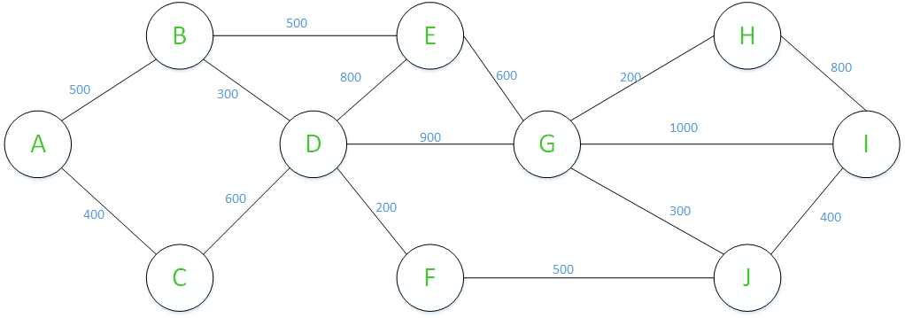

1. Assume that a series of five links each have a NF of 20 dB. Assume that the system engineering rules allow for one link in this series to have a net gain of 2 dB, as long as the following link has a net gain of -2 dB.
   1. Assuming that it is the first link in the series that is over amplified by 2 dB, by how much does the NF improve at the end of the five links?
   2. Does it make a difference if it had been the second link in the series that was over-amplified instead of the first?
   3. What is the NF at the end of the five links if the first link is under-amplified by 2 dB and the second link is over-amplified by 2 dB? Comparing this result with that of part (a), is it better from a NF perspective to under-amplify and then over-amplify, or over-amplify and then under-amplify?
2. Assume that a network has span distances of 80 km, and assume that Raman amplification is being used, where the Raman gain is set equal to the span loss. Assume that the overall NF for an amplified span with 20-dB loss is 18.5 dB, and assume that the NF decreases linearly by 0.75 dB for every 1-dB decrease in span loss. Assume that the system can tolerate a cumulative NF of 33 dB before requiring regeneration.
   1. Assume that legacy fiber is deployed, with a loss of 0.23 dB/km. What is the optical reach on this fiber (ignore any effects other than fiber loss)?
   2. Assume that new fiber is deployed, with a loss of 0.19 dB/km. What is the optical reach on this new fiber?
3. Assume that a system has a hybrid two-stage amplifier, where the first stage is Raman based, with a maximum gain of 18 dB, and the second stage is EDFA based, with a maximum gain of 7 dB. Assume that the amplifier is placed at the end of a span that has a total loss of 20 dB, and assume that the net gain, after both stages of amplification, should be 0 dB. The Raman amplification is distributed over the fiber span that precedes it (i.e., treat the fiber span and the Raman amplifier as one stage). At 13-dB Raman gain, the NF for the first stage is 21 dB; assume that the NF decreases linearly by 0.25 dB for every 1-dB increase in Raman gain. The NF of the EDFA stage is fixed at 6 dB regardless of its gain. What should the gain settings be for the Raman and EDFA portions of the amplifier to minimize the overall NF, and what is the overall NF of the two-stage amplifier?
   1. Which one of multistep RWA and one-step RWA imposes more practical complexity? Which one of those algorithms yields better results usually? Suppose that a network is not heavily loaded. Which algorithm is better to be deployed and why?
   2. What is the motivation of using Most-Used algorithm in wavelength assignment?
4. Consider the network topology and the traffic matrix shown below. Assume that a maximum of two wavelengths is supported at each link (bidirectional links contain two optical fibers in opposite directions). Seven connection requests are presumed according to the traffic matrix shown below which arrive at the network nodes in the following order: (1 – 3 ) , (2 – 6 ), (3 – 5), (4 – 2), (5 – 2), (6 – 5), (7 – 5) . Apply the First-fit and Most-Used Wavelength assignment schemes to this problem. Is it possible to fulfill all the connection requests?

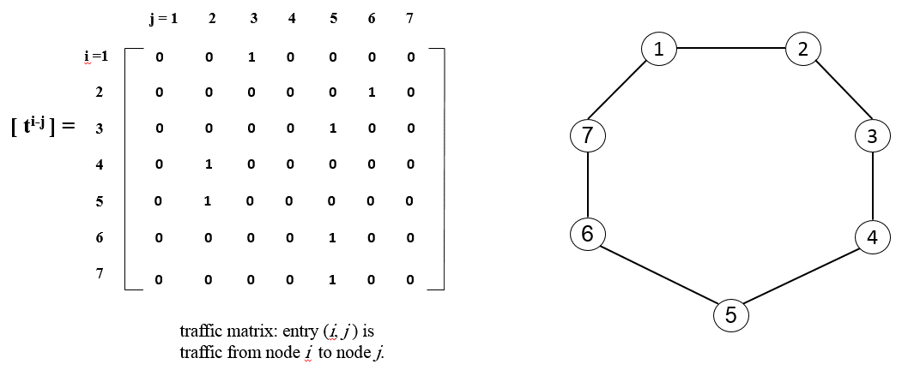

1. Assume that the network shown below supports a maximum of three wavelengths per fiber. The eight demands shown are received in one batch. The connections are numbered by their wavelength assignment order; i.e., Connection 1 is assigned a wavelength first. Apply the First-Fit, Most-Used wavelength assignment schemes to this example, and report the wavelength assignment results. (In any of the schemes, if there is a tie regarding which wavelength to select, choose the lowest-indexed one.)

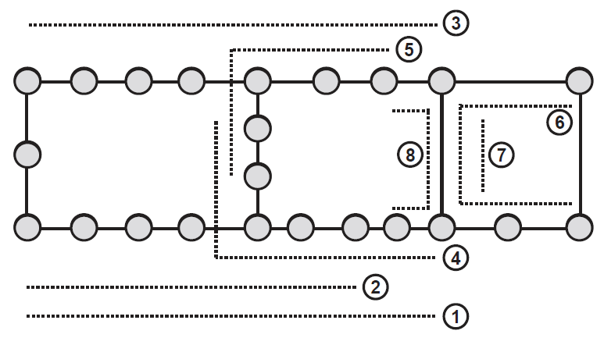

1. Consider the six light paths in the network topology shown below:

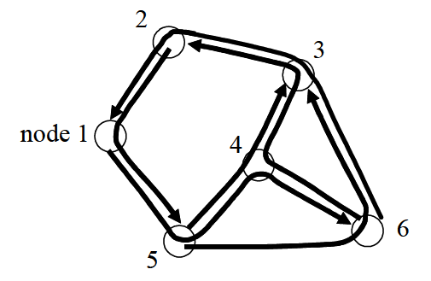

* 1. Draw the path graph associated with the given light paths and their routes and identify the node order (from first to last) for Largest Degree First (LDF) sequential coloring heuristic.
  2. Based on the topology graph produced in part a, what is the minimum number of wavelengths needed for wavelength assignment?
  3. Assume that wavelength conversion occurs at Node 4. Determine the minimum number of wavelengths needed for wavelength assignment in this case?

1. Consider the connection pattern shown below. Draw the path-graph and apply the LDF graph-coloring scheme to that. Assume that there is a maximum of three wavelengths per fiber (i.e., three colors). In what order are the nodes of the path-graph assigned colors? Combine this ordering with the First-Fit wavelength assignment scheme. What is the result? (If multiple nodes are tied for the largest degree, then the node corresponding to the connection with the most hops is selected)

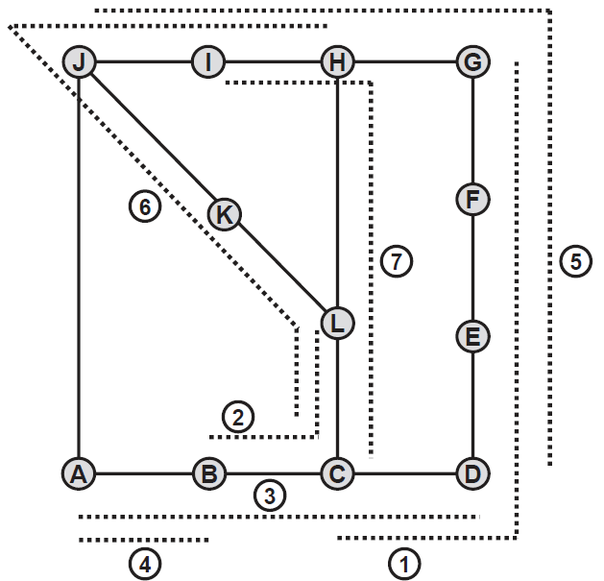

1. Consider the physical topology shown below.

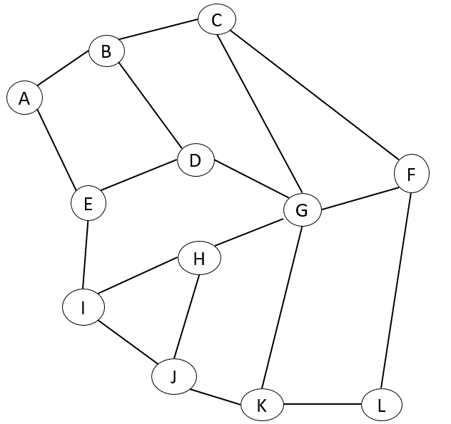

Suppose that a failure occurs in link J-K and the requests between nodes are as shown in the table below. Use LDF scheme to sort the requests. What is the minimum number of wavelengths required? (Consider the cost of all links equal to 1)

|  |  |
| --- | --- |
| (s-d) pairs | (s-d) pairs |
| A-H | G-J |
| B-F | H-E |
| C-F | I-K |
| D-E | J-H |
| E-F | K-D |
| F-H | L-C |